Afik Yefet - AI Crypto Advisor
AI Crypto Advisor - User Overview
AI Crypto Advisor is a personalized crypto dashboard that learns your interests and shows tailored market data, news, and AI insights.
What It Does
The app helps you:
- See crypto prices and trends
- Read crypto news aligned with your interests
- Get a daily AI insight
- Browse crypto memes
- Improve recommendations by voting on content

Getting Started
Sign up or log in - Create an account or sign in with email and password.
Onboarding - New users answer a short quiz:
Favorite coins (e.g. Bitcoin, Ethereum, Solana)
Investor type (HODLer, Day Trader, NFT Collector)
Content type (Market News, Charts, Social, Fun)
Dashboard - After onboarding, you see your personalized dashboard.

How Personalization Works
The app uses your onboarding answers and votes (up/down on coins, news, insights, memes) to:
- Choose which coins to show first
- Filter news by topics and style
- Generate daily insights
- Improve recommendations over time

Navigation
Route | Description
/ | Main dashboard (requires login)
/login | Login or sign up
/onboarding | First-time setup (redirects here if not completed)
/preferences | Edit preferences

Links
GitHub: https://github.com/afikyefet/Afik-Yefet---AI-Crypto-advisor
Frontend: https://afik-yefet-ai-crypto-advisor.vercel.app/
Backend: https://afik-yefet-ai-crypto-advisor.onrender.com
Used Stack
Frontend:
React 19
Redux
React Router
Vite
Axios
Sass
Backend:
Node.js + Express.js
MongoDB
JWT
bcrypt

API’s:
CoinGecko API - Crypto market data
CryptoPanic API - Crypto news
Reddit meme API - Crypto memes
OpenRouter API - AI Advisor

Deployment:
Render - Backend hosting
Vercel - Frontend hosting

Additional tool’s:
Postman
Jest
Cursor
Codex

Bonus - Suggestion about the process of training AI
My suggestion about the process of training is to put emphasis on the documentation of the votes so we can get better metrics regarding the user’s behavior and preferences. I would save in the vote the userId, section type, voting time, content, context (what the user saw and the prefs of him and the ai at the moment ov voting). Using this data we could extract metrics like “like-rate per section” and to see if activity is going up or down according to what the dashboard is showing and adjust accordingly.

Work accelerating with AI
In this project I worked with AI. I mainly use AI agents for the following tasks: Keeping design uniform and clean, utility tasks like installing dependencies, little favicon icon for the browser, writing tests, bridging information gaps that I would otherwise would google (except reading the API’s doc which I did myself so they can work properly), creating utility functions, demo data when needed, and asking the AI questions so we can better find the origin of errors.
It is important for me to note that I did not use AI for architecture, planning, backend logic and especially auth, and overall for the ideas. It is important for me to stay on top of my Web Apps, and I am fully immersed in the project and know its structure, data flow, and operation.

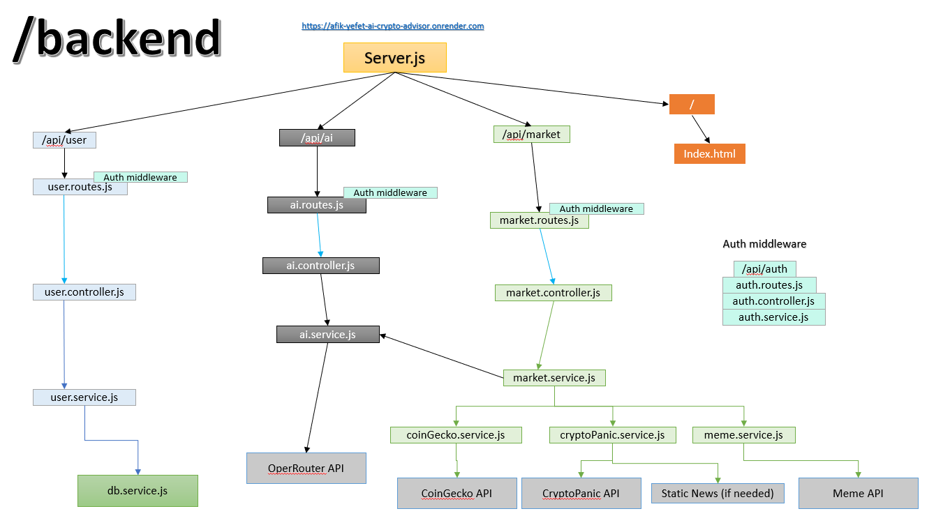
Diagrams

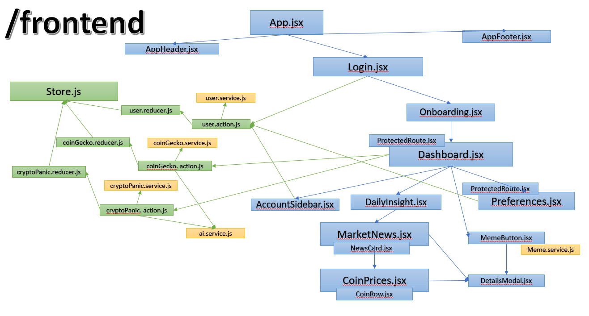

Features I would add before production
- Add rate limiting - prevent brute force attacks on login/signup
- Add Helmet.js - security headers (XSS, clickjacking, etc.)
- Add input validation - use express-validator for server-side validation
- Fix CORS - remove "allow no origin" logic
- Add request size limits - prevent DoS via large payloads
- Validate JWT_SECRET - ensure strong secret in production
- Remove sensitive data from logs - don't log full user objects

Data Structures
user
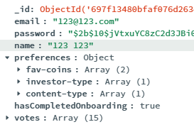
{
_id: string
name: string
email: string
preferences: { "fav-coins": string[],
"investor-type": string[],
"content-type": string[] }
hasCompletedOnboarding: boolean
votes: Vote[]
}
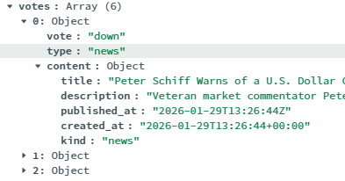
Vote
{
vote: “up”/”down”
type: “coin”/”news”
content: object
}
Daily content (MongoDB)
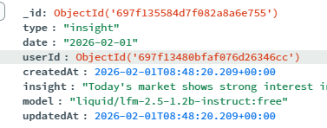
{
userId: ObjectId
date: string (YYYY-MM-DD)
type: "insight"
insight: string
model: string
createdAt: Date
updatedAt: Date
}
Relevant coins API (internal)
{ coins: ["BTC", "ETH", "SOL"] }
Relevant news filter (internal)
{
filter: "rising" | "hot" | "bullish" | "bearish" | "important" | "saved" | "lol"
currencies: string[]
kind: "news" | "media" | "all"
}
coin
{
"id": "bitcoin",
"symbol": "btc",
"name": "Bitcoin",
"image": "https://coin-images.coingecko.com/coins/images/1/large/bitcoin.png?1696501400",
"current_price": 82697,
"market_cap": 1652352274400,
"market_cap_rank": 1,
"fully_diluted_valuation": 1652353266690,
"total_volume": 91867009590,
"high_24h": 87997,
"low_24h": 81315,
"price_change_24h": -5175.387499099015,
"price_change_percentage_24h": -5.88967,
"market_cap_change_24h": -103766889572.00513,
"market_cap_change_percentage_24h": -5.90888,
"circulating_supply": 19982284,
"total_supply": 19982296,
"max_supply": 21000000,
"ath": 126080,
"ath_change_percentage": -34.40909,
"ath_date": "2025-10-06T18:57:42.558Z",
"atl": 67.81,
"atl_change_percentage": 121855.70269,
"atl_date": "2013-07-06T00:00:00.000Z",
"roi": null,
"last_updated": "2026-01-30T12:49:18.829Z"
},

news
{
"title": "Banks to lose up to $500B by 2028 as Fidelity’s digital dollar launches on Ethereum with freeze powers",
"description": "Fidelity announced the launch of a stablecoin on the Ethereum mainnet, positioning the token as a compliance-wrapped settlement dollar distributed through the firm's brokerage, custody, and wealth management channels. The move lands amid what looks like a stablecoin sprawl, as estimates suggest 59 new major stablecoins launched in 2025 alone, per third-party tracker Stablewatch.",
"published_at": "2026-01-29T12:55:20Z",
"created_at": "2026-01-29T12:55:20+00:00",
"kind": "news"
},
reddit meme
{
"title": "Crypto meme",
"imageUrl": "https://i.redd.it/abc123.jpg"
}
openRouter AI
{
"id": "chatcmpl-7aX9b2YzQ1vJkL9mN8pR4sT0wXyZ",
"object": "chat.completion",
"created": 1712345678,
"model": "liquid/lfm-2.5-1.2b-instruct:free",
"choices": [
{
"index": 0,
"finish_reason": "stop",
"message": {
"role": "assistant",
"content": "Renewable energy sources, such as solar and wind, provide sustainable power..."
}
}
],
"usage": {
"prompt_tokens": 12,
"completion_tokens": 56,
"total_tokens": 68
},
"system_fingerprint": "abc123def456"
}

